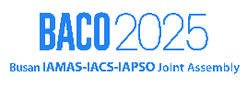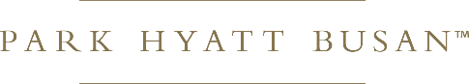

SPECIAL RATE OFFER

# We offer special rate for BACO 2025 (Busan IAMAS-IACS-IAPSO Joint Assembly 2025) as below.

|  |  |  |
| --- | --- | --- |
| **Room type** | **Room only** | **1 Adult breakfast Included** |
| Standard (King) | 250,000 | 290.000 |
| Deluxe (King / Twin) | 280,000 | 320,000 |
| Ocean View (King / Twin) | 350,000 | 390,000 |
| Ocean View High Floor (King / Twin) | 370,000 | 410,000 |
| Park Family Suite | 450,000 | 490,000 |
| Park Executive Family Suite | 510,000 | 560,000 |
| Park Executive Marina Suite | 530,000 | 580,000 |
| Park Premium Family Suite | 540,000 | 580,000 |

* Available dates: 2025. 7. 20. – 7. 26.
* The above fee is KRW. 10% tax is exclusive, and no service fee will be charged.
* Breakfast: it can be applied at a discount price of 44,000 won (including tax) per person. However, a normal price of 59,000 won (including tax) is charged when using it on-site, so a reservation is required in advance to apply the discount.
* The above charges apply only to attendees of BACO2025 (Busan IAMAS-IACS-IAPSO Joint Assembly) be closed early depending on circumstances.
* Send below information via email [[junyong.kim@hyatt.com]](mailto:junyong.kim@hyatt.com) to request reservation.

|  |  |  |  |  |  |  |
| --- | --- | --- | --- | --- | --- | --- |
| Given Name | Last Name | Check in | Check out | Room type | Breakfast (Y/N) | Remarks |
|  |  |  |  |  |  |  |

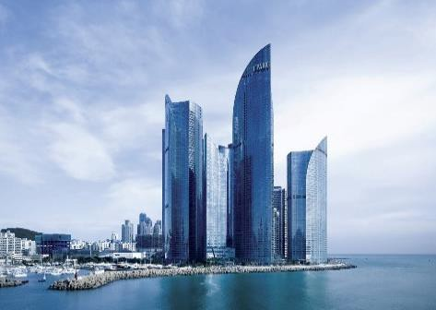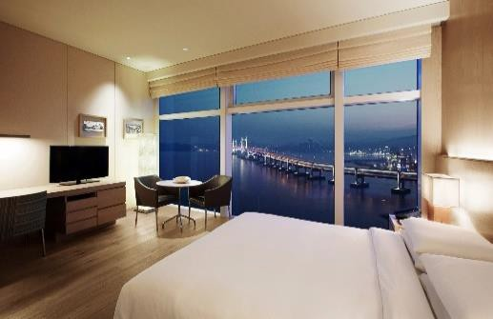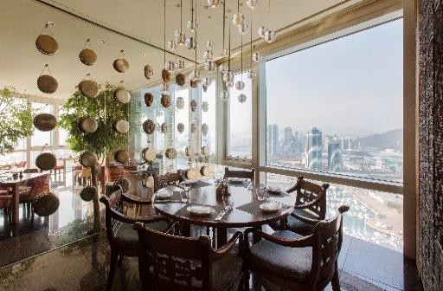

# **Inquiry** 051-990-1358 │ [Junyong.kim@hyatt.com](mailto:Junyong.kim@hyatt.com)